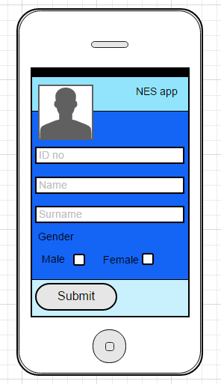BALLOT SYSTEM

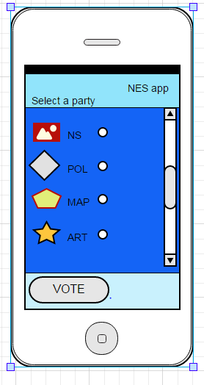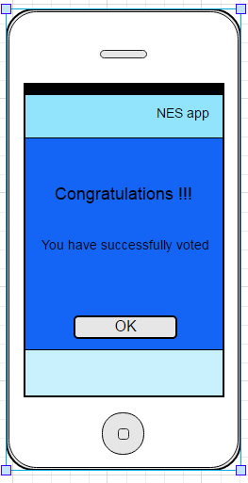

**Step 3**

If your vote is successful or not the message will alert the user

**Step 2**

The user must select the party that he/she wishes to vote for.

**Step 1**

The user inserts personal details, then press submit button to get to the next step